Warm Up:
- Complete the scene by inserting the appropriate dialogue and descriptions needed for the picture below. Consider: what should each person say in this situation?
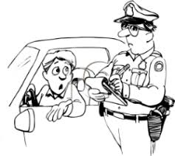

Before Reading:
- Should students be taught how to act when pulled over by the police? Why or why not?

- What is your purpose for reading the article “Why the Texas Police-Stop Video Is a Problem”

My Questions:
Question | Details from the article

Homework:
- What is your purpose for reading the article “Students must watch video on how to talk to police, or else they can’t graduate from Texas schools.”

My Questions:
Question | Details from the article

Reflect:
- What is your opinion- should students be required to watch this video in order to graduate? Why or why not? Use evidence from at least one of the texts to support your thinking.

